Experiment: 6
5G NR Frame Structure Analysis with Different Subcarrier Spacing
Objectives
1. To analyze different Subcarrier Spacing (SCS) values used in 5G NR numerology.
2. To compare the slot duration corresponding to different Subcarrier Spacing values in 5G NR.
3. To study the number of OFDM symbols present in a 5G NR slot for normal cyclic prefix.
Objective – 1: Analyze Different Subcarrier Spacing Values MATLAB Program
MATLAB Program
clc;
clear;
close all;
scs = [15 30 60 120 240]; % Subcarrier Spacing (kHz)
mu = 0:4; % Numerology Index
bar(scs)
grid on
set(gca,'XTick',1:5)
set(gca,'XTickLabel',mu)
xlabel('Numerology Index (\mu)')
ylabel('Subcarrier Spacing (kHz)')
title('5G NR Subcarrier Spacing for Different Numerologies')
OUTPUT
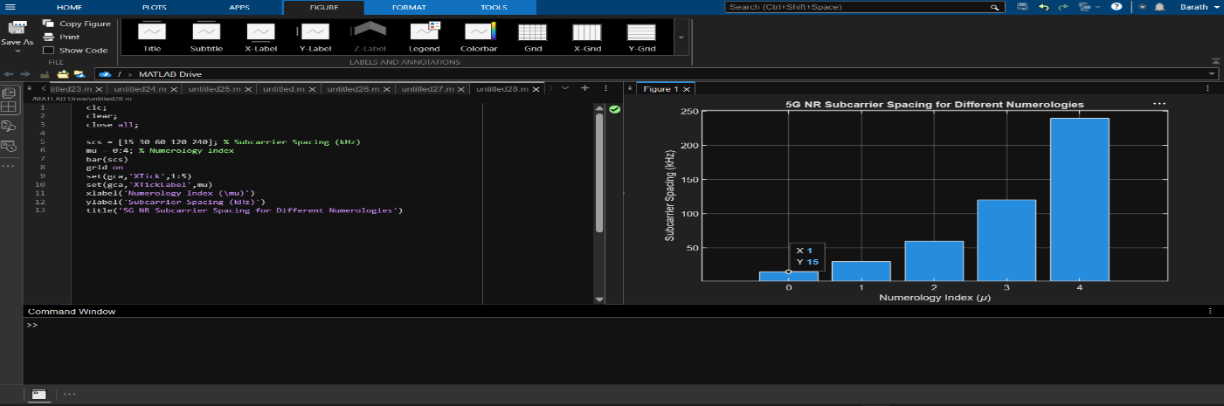

Objective – 2 Compare Slot Duration
MATLAB Program
clear;close all;
scs = [15 30 60 120 240]; % Subcarrier Spacing (kHz)
slot = [1 0.5 0.25 0.125 0.0625]; % Slot Duration (ms)
plot(scs, slot, 'o-', 'LineWidth', 2)
grid on
xlabel('Subcarrier Spacing (kHz)')
ylabel('Slot Duration (ms)')
title('5G NR Slot Duration for Different Subcarrier Spacing')
OUTPUT
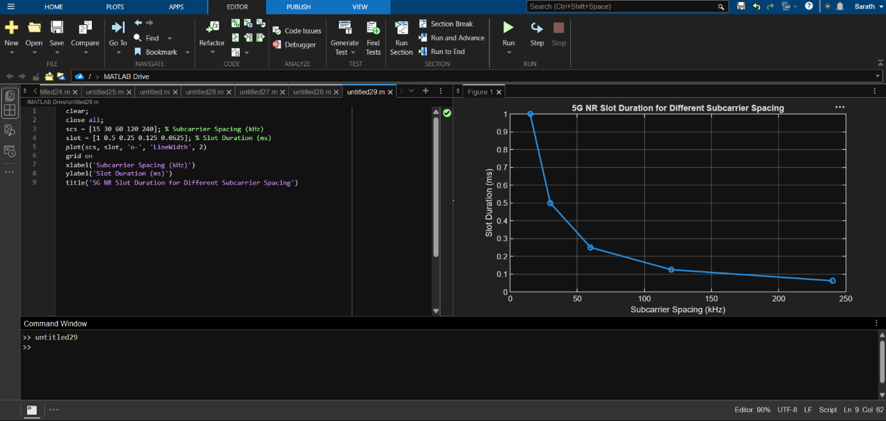

Objective – 3 Study the Number of OFDM Symbols
MATLAB Program
clc;
clear;
close all;
scs = [15 30 60 120 240]; % Subcarrier Spacing (kHz)
symbols = [14 14 14 14 14]; % OFDM Symbols per Slot
figure
bar(scs, symbols)
grid on
xlabel('Subcarrier Spacing (kHz)')
ylabel('Number of OFDM Symbols')
title('OFDM Symbols per Slot for Different Subcarrier Spacing')
ylim([0 16])
OUTPUT
